**Oracle Virtual box**

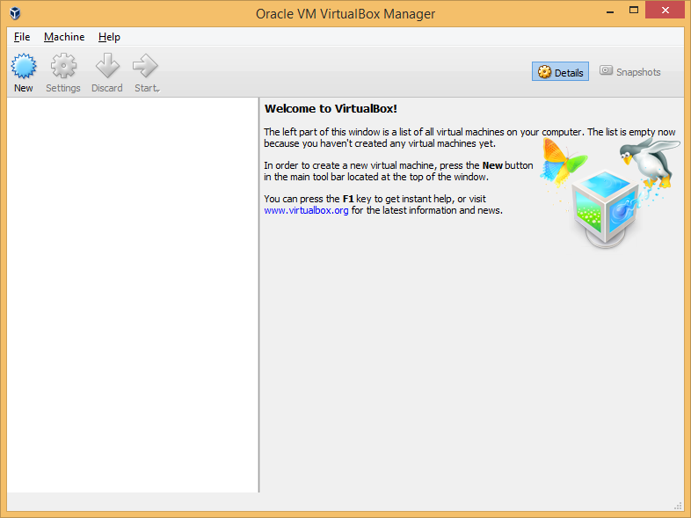

Click on new

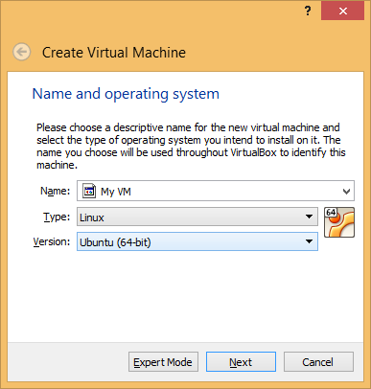

Make it 4 GB

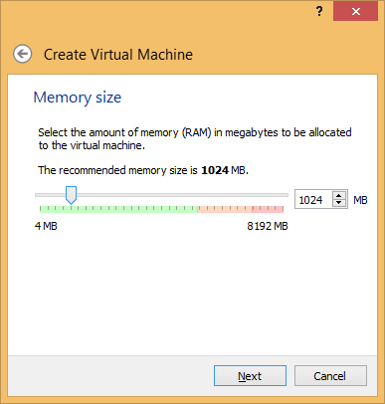

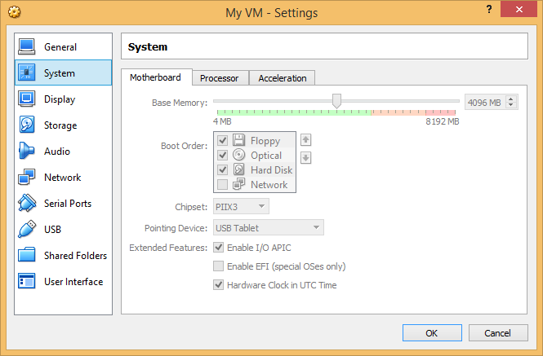

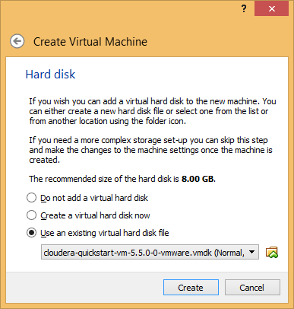

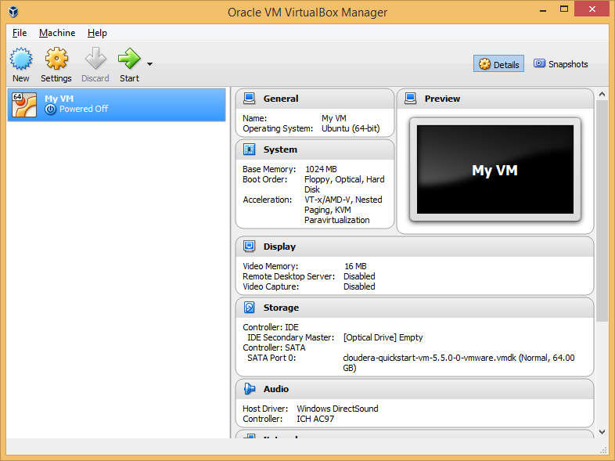

Click on Start Arrow

Image has CentOS 6.4 is installed

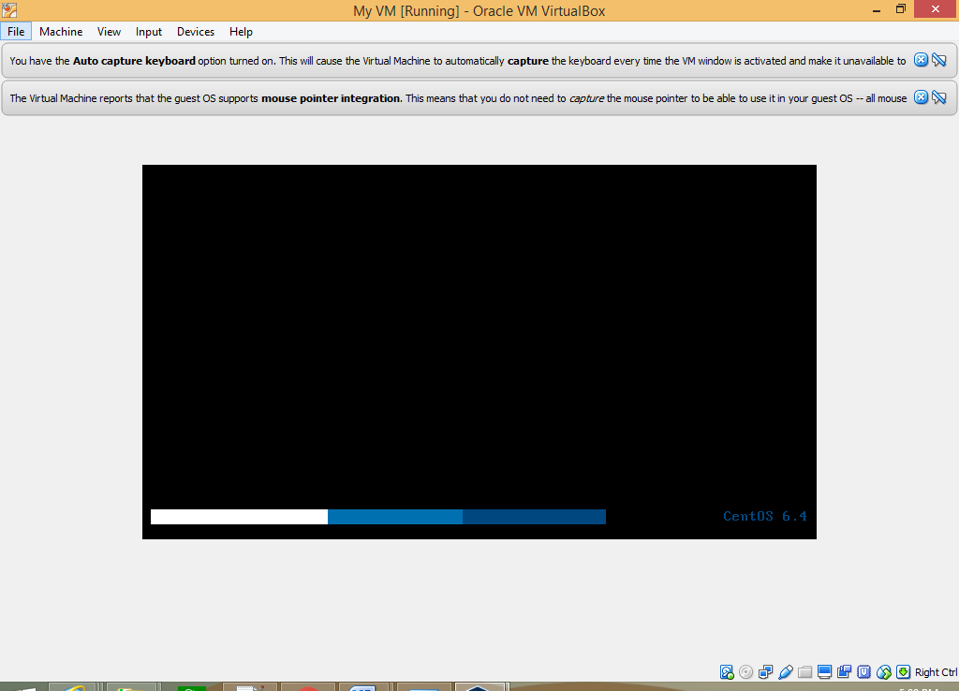

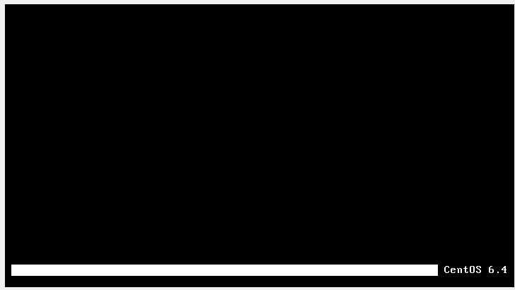

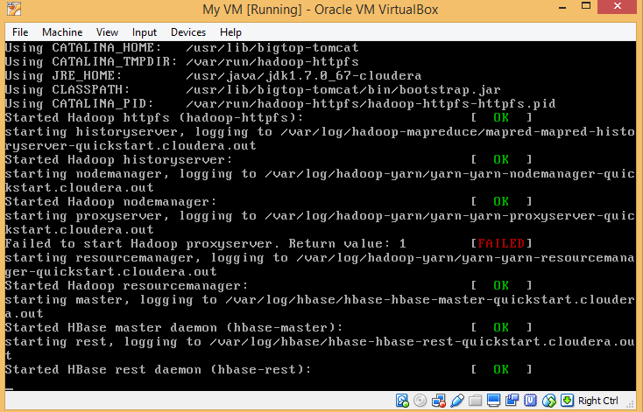

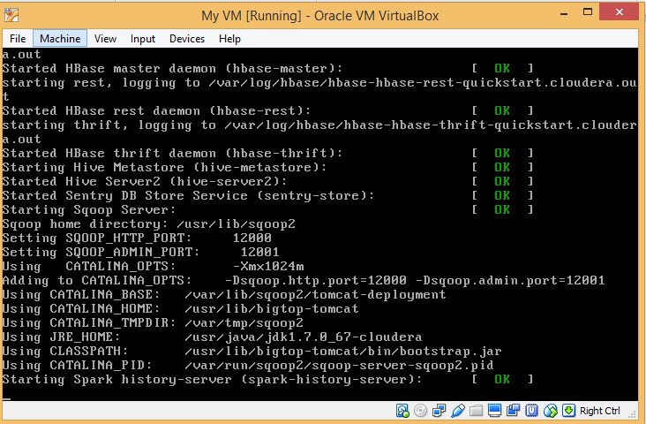

Log location - C:\Users\shalajs\VirtualBox VMs\My VM\Logs

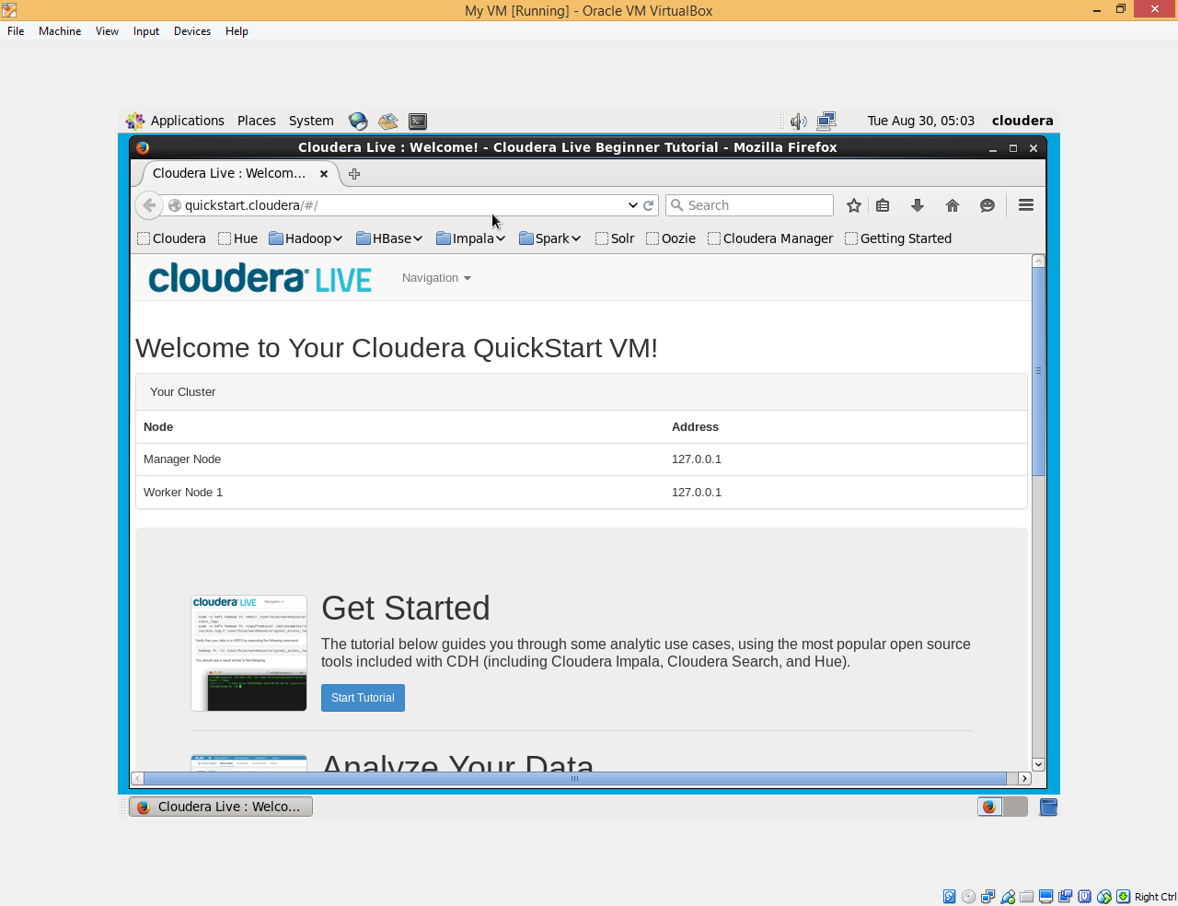

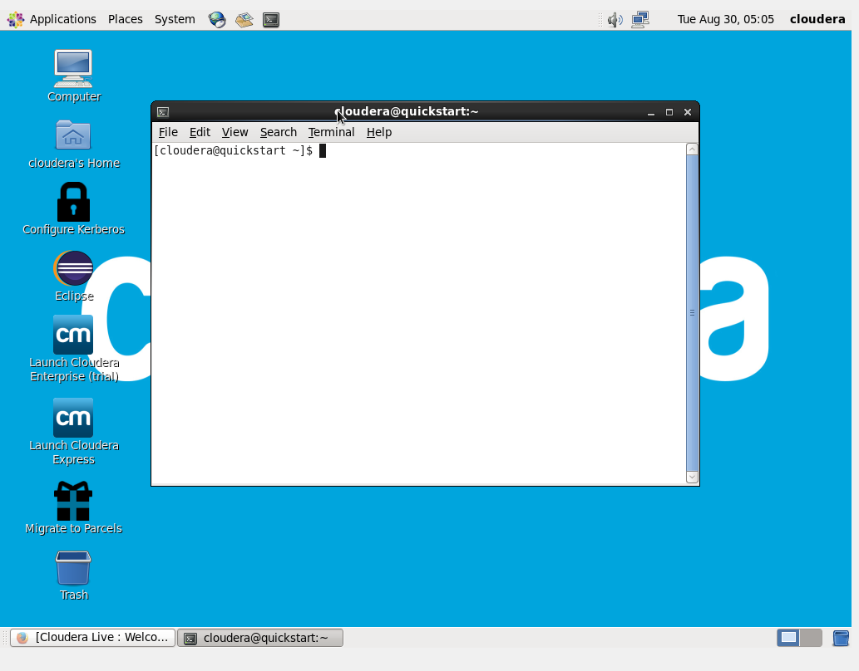

**VMWare Player**

Open VMWare player and click on Open a virtual machine

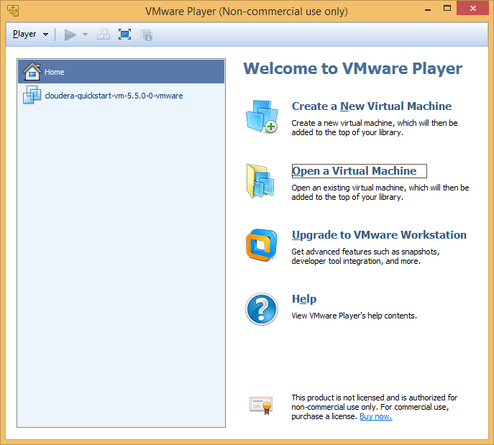

Select **cloudera-quickstart-vm-5.5.0-0-vmware.vmx**

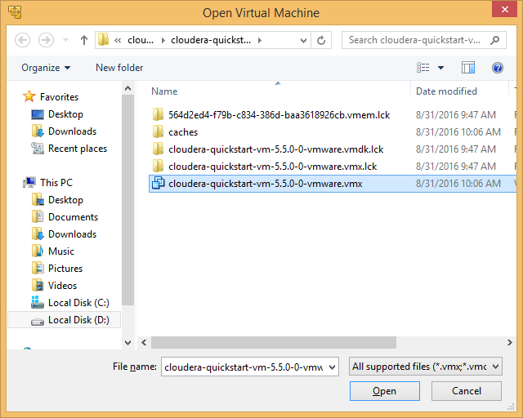

To specify shared folder please follow below steps

Go to Player>>Manage>>Virtual Machine Settings…

In options tab, select Shared Folders

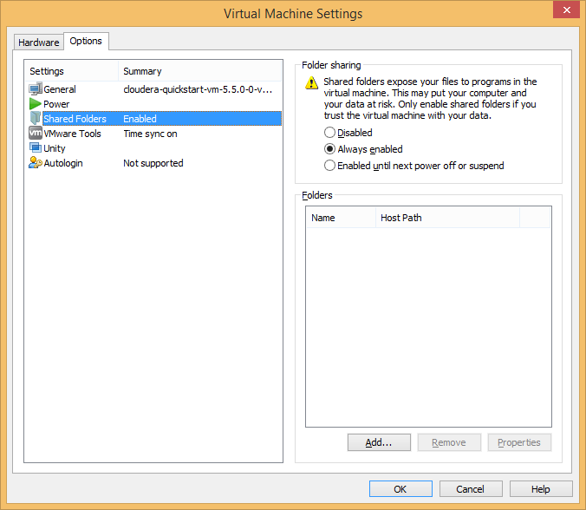

Click on Add… button

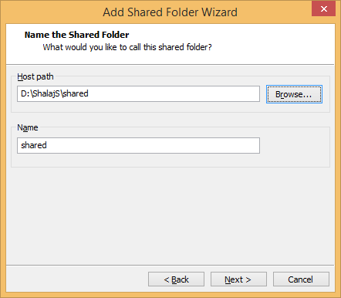

Add Host Path and click on Next

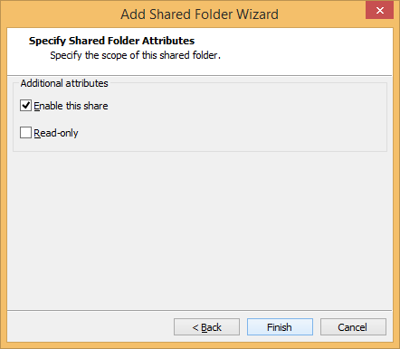

Click Finish button

Now you can access shared windows folder from virtual machine

In virtual machine follow path Computer>>File System>>mnt>>hgfs

